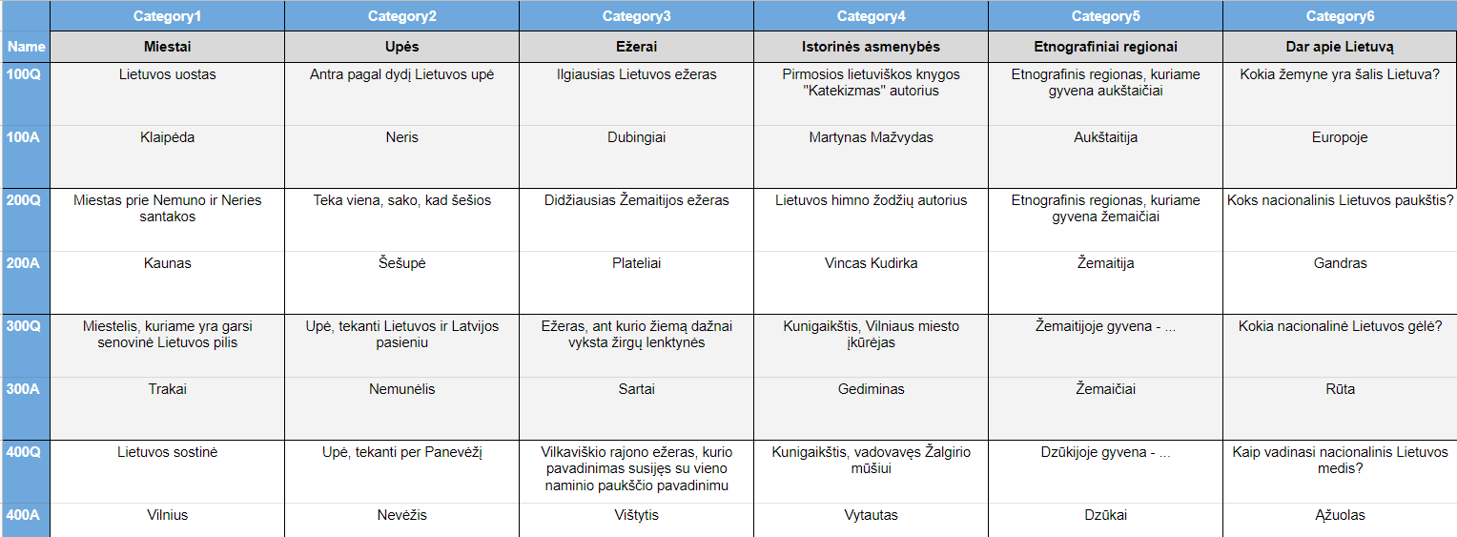

https://www.flippity.net/qs.php?k=1cA-epYz7wmEGB01rfT7myaBDJw9WGXPHlKxN53CD_ds

